**Online Test Application**

Output:

Home screen

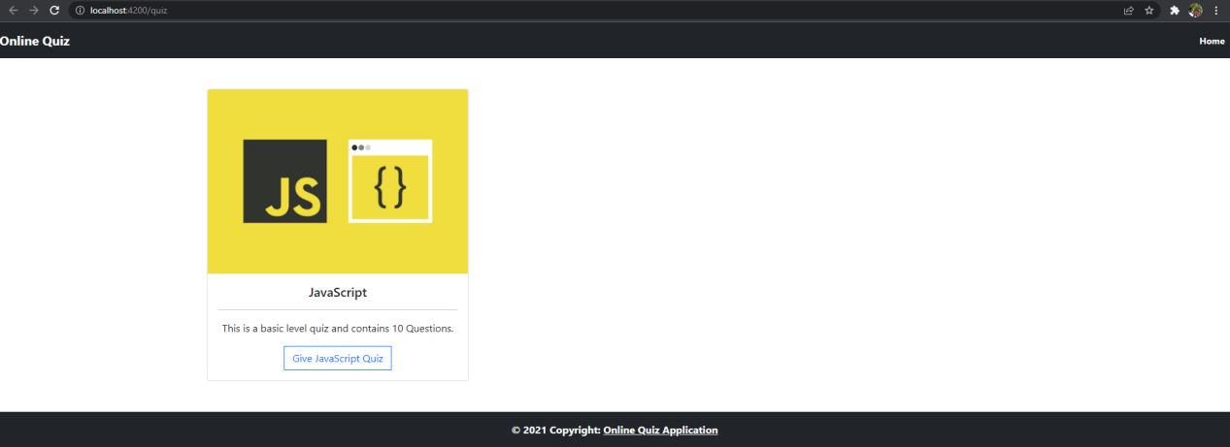

Quiz page

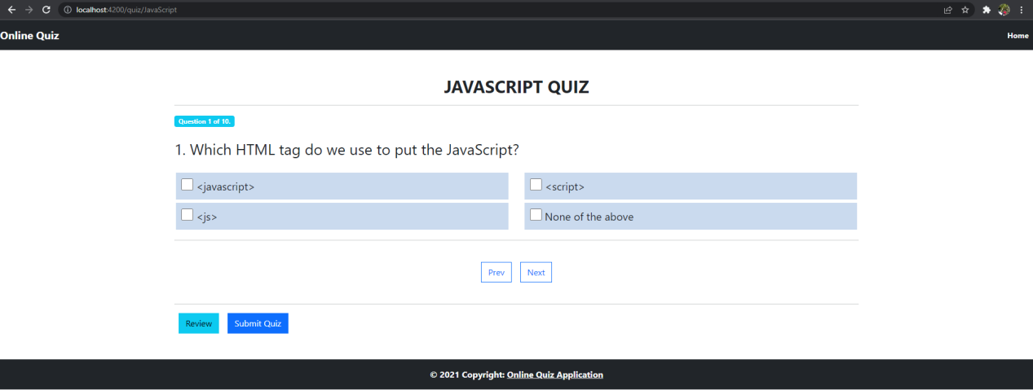

Selecting option and moving to next question using “next” button

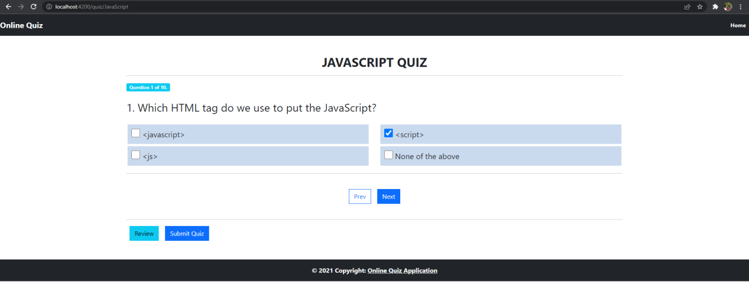

Reviewing

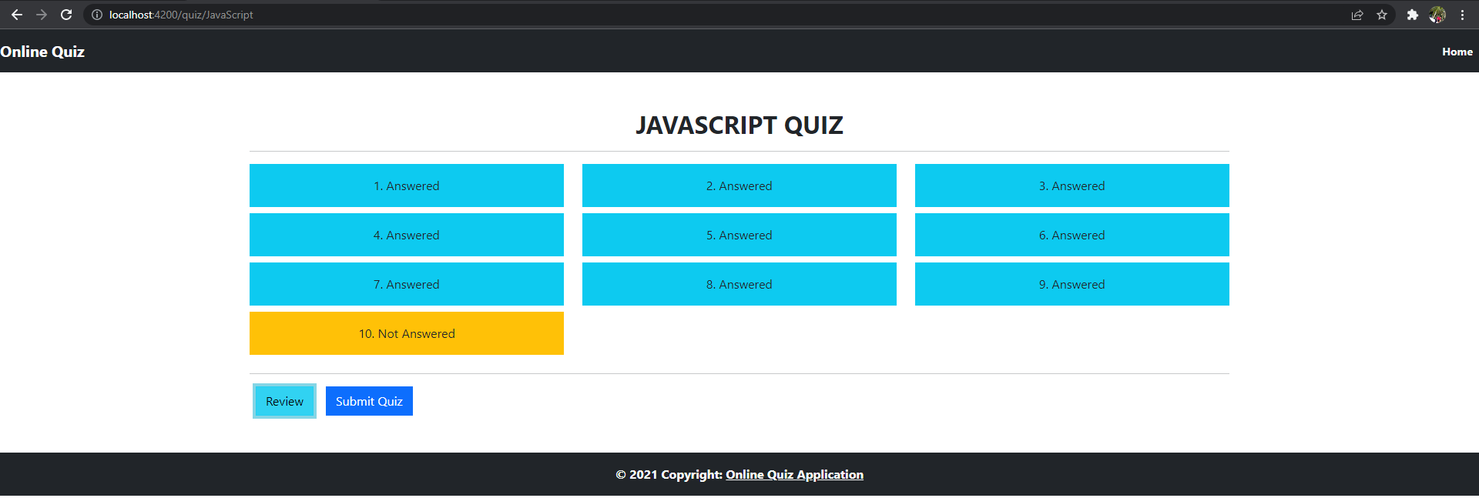

On clicking “home” button on top-right, goes to home screen

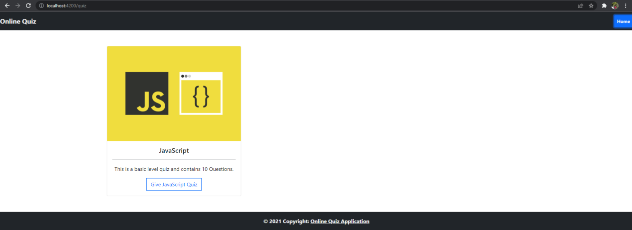

On clicking “Submit Quiz” button goes to result page and displays the result

